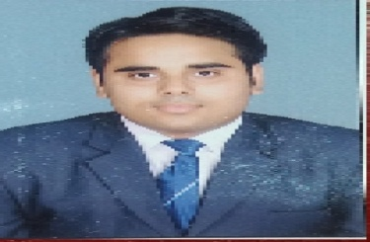 | Sahil Kakkar  E-mail : skakkar636@gmail.com  Address : Sec-2/226, Chiranjeev vihar,  Ghaziabad, 201002  Mobile N0 : 9582179302

CAREER OBJECTIVE:
To build a career in a reputed organization which will allow me to utilize my skills and knowledge to fulfill the goals of the organization?
EDUCATIONAL QUALIFICATION:
- 10 th passed from CBSE Board, New Delhi in Nehru World School, Ghaziabad with 53% Marks, year 2011.

- 12 th passed from CBSE Board, New Delhi in Nehru World School, Ghaziabad with 66% Marks, year 2013.

- Graduation BBA is completed in INMANTEC Business College, Ghaziabad from CCS University, and Meerut with 56% Marks, year 2016.

- Preparation of Government Service examination and Digital Marketing Diploma and other courses Tally etc (2017-2020).

- Post-Graduation MBA Finance and hr is completed in INMANTEC Business College, Ghaziabad from AKTU University, Lucknow with 65% Marks, year 2020-2022.

- 2022-2023 BPO Job

- 2023-2024 Digital Marketing Job

- 2024-2025 Data Entry Job

TRAININGS COURSE UNDERTAKEN:
- Certificate Training (Internship) at SLA CONSULTANTS INDIA.

PROJECTS:
- Dashboard in Excel
- Dashboard in Power BI

KEY SKILLS:
- Excel
- Power BI
PERSONALITY TRAITS:
- Honest and self – confident.
- Dedicated and hardworking.
- Strong learning skills.
AREAS OF INTEREST:
- MBA ( HR)
PERSONAL DETAILS :
- Date of Birth : February 5, 1996
- Father Name : Mr. Krishan Kumar Kakkar
- Language Known : Hindi, English
- Permanent Address : Sec-2/226, Chiranjeev Vihar ,
Ghaziabad (201002)
- Hobbies : Travelling , Sports
- Nationality : Indian
- Gender : Male
- Marital Status : Un-Married
DECLARATION:
I hereby declare that the information furnished above is true to the best of my Knowledge and belief.

Date: Place: Signature:

